Implement Intersite Connectivity

Task 1: Provision the lab environment

Uploaded files, created 3 virtual machines and three vnets. The first two vnest are in East US and the third is in West US.

Task 2: Configure local and global virtual network peering

Whit a little bit of waiting I managed to establish two local peerings between vnet1 and vnet0.

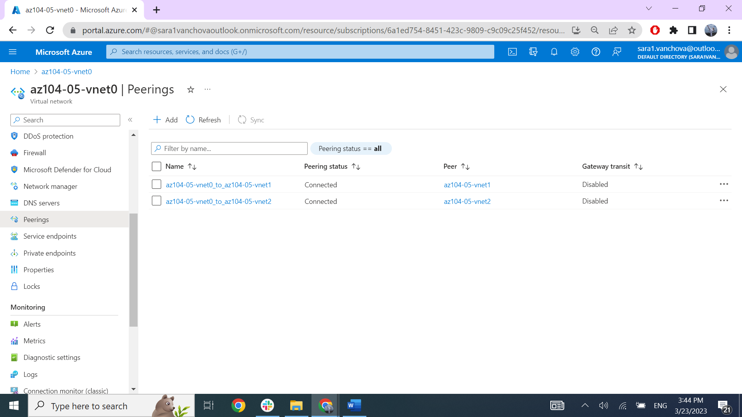

With powershell I established global connection between vnet0 and vnet2. (I did this with powershell because vnet2 wasn’t showing up for selection because is in a different region from the other vnets).

Task 3: Test intersite connectivity

Connectivity from vm0 to vm1

Connectivity from vm0 to vm2

Connection between vm1 and vm2